**14.USING RAPTOR –POSITION OF NUMBERS**

**Y.Naveen kumar reddy   
192111405**

**FLOWCHART:**

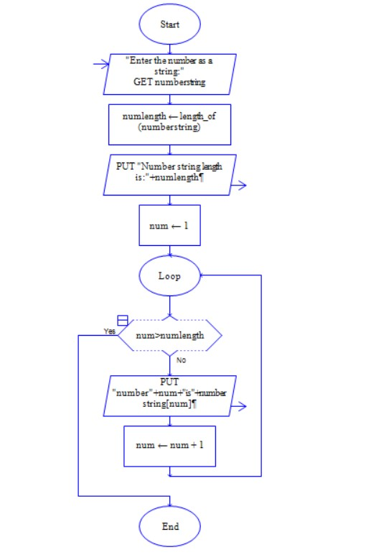

**OUTPUT:**

INPUT:Naveen

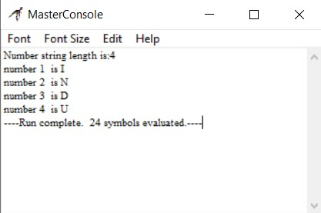

**RESULT:**

The program is executed and verified successfully.